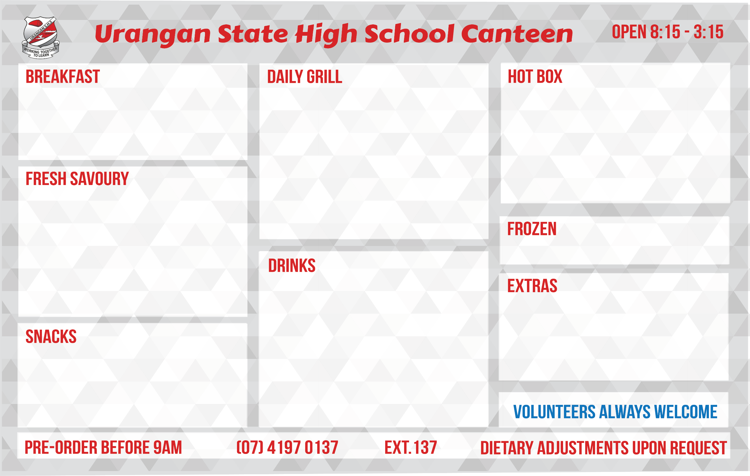

Up & Go

**Term 2/3**

1.20

2.20

3.00

4.50

4.50

4.50

2.50

2.00

3.00

4.00

2.80

3.50

1.00

Milk Plain 300ml

Plain 500ml

Flavoured 300ml

Flavoured 500ml

Oak Flavoured 600ml

Baristas 500ml

LACTOSE AND DAIRY FREE VARIETY AVAILABLE

Bottled Juices from

Fruit Juice Poppers from

V8 Vegie Juices from

Pump Water 750ml/Flavoured

Mount Franklin Water 600ml

Water 1.5 litre

Water from

5.00

6.00

6.00

6.00

6.50

6.50

6.50

6.80

5.80

5.50

6.80

6.50

**MONDAY** Beef and Cheese

**TUESDAY** Chicken BLT

Lamb and Caramelised Onion

Beef and Caramelised Onion

**WEDNESDAY** Lamb, Cheese and Bacon

Chicken, Cheese and Bacon

Beef, Cheese and Bacon

**THURSDAY** Chicken Caesar

Flame Grilled Chicken

**FRIDAY** Chicken Burger

Hawaiian Burger

Vegan/Vegetarian Burger (by order) from

1.00

Assorted Ice Creams from

*Streets, Peters*

3.00

0.50

3.60

6.50

5.00

4.50

5.50

6.50

6.80

3.00

3.00

4.00

3.80

Toasted Extra

½ Lavash

Lavash

Sandwiches – Assorted Fillings

Small Round Rolls

Large Round Rolls

Knot/Scotch Rolls from 6.00

Turkish Pide Rolls Half $3.60 Full

Assorted Salads from

Caesar Salad Packs from

Chicken Caesar Salad Pack from

Pasta Packs Plain $2.60 Mixed

2.50

1.00

3.00

3.00

3.50

4.50

1.00

1.80

Assorted Banana Breads

Assorted Cakes and Slices from

Apple Slice

Yoghurt and Muesli from

Watermelon Bowls

Fruit Bowls from

Cheese Squares x 4 from 50c

Crackers from 20c

1.00

0.10

0.30

0.20

5.00

5.00

5.20

5.00

3.30

3.80

6.00

6.00

4.60

4.00

Chicken/Beef/Pork Gravy Rolls from

Lasagne – packaged $4.80 Home made

BBQ Pork Riblet and Bacon Wrap

Meatball and Sauce Roll from

BBQ Pork Riblet Small $2.80 Large

Chicken Fillet Roll with Mayo/Sweet Chilli from

Pie – Plain from 2.00

Pies Assorted from 5.60

Sausage Rolls from 4.00

**Term 2/3**

Dim Sims (3) Tuesday

Assorted Savoury Snacks from

Spoons and Forks

Sauce Sachets

Soy Sauce from