YEAR 10 SUBJECT

SELECTION GUIDE

Subject Offering



**Table of Contents**

Science Faculty 2

Creative Futures Faculty 3

Technologies Faculty 5

Math Faculty 7

English Faculty 9

HPE Faculty 10

Humanities and Languages Faculty 11

Vocational Education 14

Special Education 15

Science Faculty

# Overview

In Year 10 Science there are two options for students:

1. Science foundation
2. Science extension

Both subjects will cover:

* Processes that underpin heredity and genetic diversity
* Evidence supporting the theory of evolution
* Key events in the origin of the universe and the supporting evidence for the big bang theory
* Trends in patterns of global climate change and identify causal factors
* How Newton’s laws describe motion and apply them to predict motion of objects in a system
* Patterns and trends in the periodic table
* Predicting products of chemical reactions

# Science Foundation

Students who should be selecting this subject are:

* Wanting/thinking about doing applied science in senior and/or
* Applied/workforce bound
* If you are not passing science in grade 9. You must select this subject.

Science foundation will allow students to explore inquiry-based learning and how science applies to the workplace.

# Science Extension

Students who should be selecting this subject are:

* Wanting/thinking about doing ATAR general science in senior (Biology, Chemistry, Marine Science, Physics, Psychology QVA) and/or
* Potentially university bound and/or
* Doing well in science currently

Science extension will build students competency towards completing the style of assessments seen in ATAR marine, biology, chemistry, physics and psychology.

For more information, please contact: Mr Anthony Clancy, Head of Department Science

[aclan7@eq.edu.au](mailto:aclan7@eq.edu.au)

Creative Futures Faculty

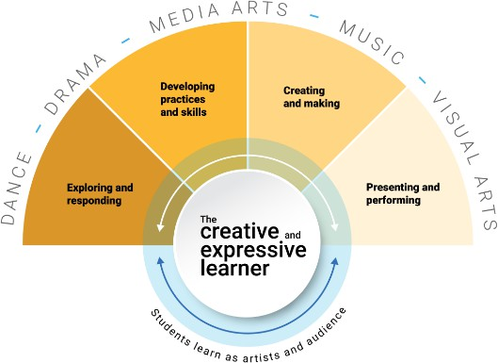

The big ideas central to studying an Arts subject are:

* All students have creative and expressive potential
* Creative processes are flexible and cyclical; they involve doing

and knowing

* As artist you learn from the work you create, as audience, from

the work you experience

* Making and responding are interwoven creative processes
* Critical engagement with arts works and practices develops empathy and contributes to the lives of people, cultures and communities.

# Dance

In Dance, you’ll explore and reflect on the world around you through movement and creative thinking. You’ll use your body to express ideas and communicate messages. Dance helps you grow as a whole person, giving you ways to understand yourself, others, and the world. You’ll be assessed through Choreography, Performance, and Responding to your own and others’ dance works.

Studying Dance in Year 10 is *recommended* for students who plan to study General Dance (ATAR) and/or Certificate III in Dance (Workforce) in senior.

# Drama

In Drama, you’ll explore what it means to be human by creating and sharing stories, emotions and ideas. You’ll use your imagination, creativity and performance skills to create and perform drama, and respond to dramatic works. You’ll be assessed through Devising Drama, Performance and Responding to your own and others’ dramatic works. Drama is a subject that develops confidence and the ability to collaborate with others.

Studying Drama in Year 10 is *recommended* for students who plan to study General Drama (ATAR) and/or Drama in Practice (Workforce) in senior.

# Music

In Music, you’ll explore creative ways to express yourself. You’ll build your skills through Making (Composition and Performance) and Responding (Musicology). You’ll create original music using what you’ve learned, and show your skills by performing solo or in groups. You’ll be assessed through Performance, Composition and Responding to your own and others’ music.

Studying Music in Year 10 is *recommended* for students who plan to study General Music (ATAR) and/or Certificate IV in Music (Workforce) in senior, and Music Extension (ATAR) in Year 12.

# Media Arts

In FTVNM, you’ll build skills in creativity, teamwork, planning, and thinking critically about what you watch and create. You’ll learn how to understand and analyse visual media, then use that knowledge to plan and make your own films and moving image content. You’ll be assessed through processes such as developing Treatments and Scripts, Producing Films, and Responding to your own and others’ screen works.

Studying Media Arts in Year 10 is *recommended* for students who plan to study General Film, Television & New Media (ATAR) and/or Certificate III in Visual Arts – Photography (Workforce) in senior.

**Visual Arts**

In Visual Art, you’ll create artworks using different materials and art making techniques, exploring ideas in response to a variety of concepts. You’ll experiment, problem-solve and use visual language to express your ideas, perspectives and feelings. You’ll also learn about the role of art in different times and cultures. Assessment includes developing experimental works, resolving two and three-dimensional artworks, and responding to your own and others’ visual art.

Studying Visual Arts in Year 10 is *recommended* for students who plan to study General Visual Art (ATAR), Visual Arts in Practice (Workforce) and/or Certificate III in Visual Arts - Photography (Workforce) in senior.

**Certificate III in Dance**

This course is a preparatory path for students who want to develop their skills in dance and performance for the live entertainment industry or teaching. You’ll grow your technique, learn how to work with others, and stay on top of tasks and deadlines. You’ll have chances to perform at events like Dance Night, multi-arts shows and graduation events. Assessment is based on showing you can do the kind of work expected in real performance settings.

Studying this course in Year 10 is *required* for students who plan to study Certificate III in Dance (Workforce) in senior. This course is available for study in Semester 2.

**Certificate III in Visual Arts (Photography Specialisation)**

This course is a preparatory path for students looking to develop their photography skills. You’ll get hands-on experience with studio and outdoor photography and learn how to edit your images using Adobe Photoshop and Lightroom. This course gets you ready for work in the photography industry or to build your own photography practice. You’ll be assessed on your ability to do tasks expected in the industry.

Studying this course in Year 10 is *required* for students who plan to study Certificate III in Visual Arts - Photography (Workforce) in senior. This course is available for study in Semester 2.

**Certificate IV in Music**

This course is a preparatory path for students looking to develop real skills in music performance, sound production, or the music industry. You will participate in a program intended to develop the musical skills and knowledge required to achieve successful completion of competencies in Year 11 and 12 when you take ownership of Music events such as Acoustic Night and SONIC. You’ll be assessed on how well you can do tasks that are expected in the music industry alongside developing your performance abilities, learning how to work in teams, solve problems, and manage projects.

Studying this course in Year 10 is *required* for students who plan to study Certificate IV in Music (Workforce) in senior. This course is available for study in Semester 2.

For more information, please contact: Ms Liza Young, Head of Creative Futures [lyoun50@eq.edu.au](mailto:lyoun50@eq.edu.au)

Technologies Faculty

**Digital Technology**

Digital Technologies empowers students to develop the skills and knowledge needed to thrive in a data-driven world. Through engaging, real-world challenges, students explore how digital systems operate and learn to design solutions that address practical problems. With a focus on innovation, creativity and ethical understanding, students gain insight into how digital tools shape the modern world.

In this subject, students will complete a coding project where they design and develop their own interactive game. They will also learn to use databases to store and retrieve game-related data such as high scores and player progress, gaining essential skills in data modelling and management. Students will also explore the world of cyber security --learning how digital systems manage access to information and simulating a cyber-attack scenario to better understand vulnerabilities, digital footprints and data protection strategies.

This subject is ideal for students interested in programming, ethical technology use, and the digital systems that underpin entertainment, business and communication in today's society.

**Certificate II in Engineering Pathways (Drones)**

Is a year-long subject that leads into the Certificate III in Aviation where students are able to obtain a license to fly remote piloted aircraft. In the Certificate II program, students are able to build a drone that can be used in the Cert III training. There is no cost involved to students (VETiS funding utilised).

**Materials and Technology Specialisation One (TMT)**

The focus of this subject is to challenge students to design and create solutions using their knowledge and understanding of a range of materials like timber, metal and plastics. Students will investigate current industry trends and construction styles and will create solutions using various production techniques and technologies that are used in the industrial fabrication workspaces. Students will have the opportunity to develop a comprehensive understanding of traditional, contemporary and emerging materials and technologies (tools and machines), that will assist them to generate and produce design solutions for authentic needs while considering sustainable design practices. This subject also aims to develop students’ ability to work individually and collaboratively to investigate, design, plan, manage, create and evaluate their solutions. By completing this subject, it prepares students for further study in the subject areas of Building and Construction, Furnishing and Engineering Skills.

**Materials and Technology Specialisation Two (TTZ)**

Students explore the exciting world of design through the creation of wearable devices or production of designed resources. This subject focuses on developing practical skills in textile construction and surface decoration while encouraging innovative thinking and sustainable design practices. Students investigate current fabrication trends, consider user needs, and apply design processes to produce functional and aesthetically appealing garments or accessories. Students will have opportunities to experiment with digital design tools, sublimation printing, and laser cutting to create unique surface patterns and components. These advanced techniques allow students to personalise their work and push the boundaries of traditional design. Through hands-on activities, students will work with a range of textile materials and technologies, using industry-standard tools and equipment to prototype and refine their work. This course prepares students for further study in design, and encourages them to think critically about fashion’s impact on society and the environment.

**Engineering Principles and Systems (TES)**

Students will explore the study of mechanics, materials science and control technologies through real world engineering contexts where students engage in problem-based learning. Students will learn to explore complex, open-ended problems and develop engineered solutions using a large range of materials and construction techniques. The problem-based learning framework in this subject of Engineering encourages students to become self- directed learners and develop beneficial collaboration and management skills. This subject provides students with an opportunity to experience, first-hand and in a practical way, the exciting and dynamic work of real-world engineers. Students will also have access to learn information & communication technologies (ICT) skills by experimenting with digital design tools like CAD software, laser cutters and 3D Printers. The problem-solving process in this subject of engineering involves the practical application of science, technology, engineering and mathematics (STEM) knowledge to develop sustainable products, processes and services. Students who study this subject will develop technical knowledge and problem-solving skills that enable them to respond to and manage ongoing technological and societal change. This subject prepares students who are looking at completing Senior Engineering, Science and Mathematical subjects.

**Food Specialisations**

This subject will focus on design and being able to create solutions to maintain and enhance individual and community health involving knowledge and understanding of what constitutes healthy and sustainable food systems to make informed food selection and preparation choices.

Food specialisations will develop knowledge and techniques focusing on methods of cookery and food production. Students will undertake two units: the first one will concentrate on different methods of cookery and allow students to trial and sample a range of techniques. The second unit will focus on food production and will culminate in authentic production experience.

For more information, please contact: Mrs Stephanie Whitehead, Head of Department Technologies [swhit365@eq.edu.au](mailto:swhit365@eq.edu.au)

Math Faculty

**Mathematics (MAT)**

Students will study a range of topics including financial mathematics, patterns and algebra, linear and non- linear relationships, logarithmic scales, measurement, networks, geometric reasoning, trigonometry, chance, and data representation and interpretation.

Prepares students for General or Essential mathematics in Year 11 and 12. This is for students who are interested in either a workforce or University pathway that does not require advanced levels of mathematics.

**Extension Mathematics (MAX)**

Students in this class will explore the full range of Year 10 Mathematics topics while extending their learning into advanced areas such as surds, logarithms, complex algebraic techniques, trigonometric functions, and mathematical proofs.

Designed for high-achieving students, this course provides a strong foundation for Mathematical Methods and Specialist Mathematics in Years 11 and 12. It is ideal for those pursuing a university or trade pathway in fields that require advanced mathematical skills. Entry is recommended for students achieving an A or B in Year 9 Mathematics.

**Pre-Specialist Mathematics**

Pre-Specialist Mathematics is an elective option offered in Semester 2 Year 10 (dependent on timetable availability), to help develop the mathematical skills needed to succeed in Specialist Mathematics. Topics include Complex numbers; Arithmetic and Geometric Sequences; Vectors and Matrices.

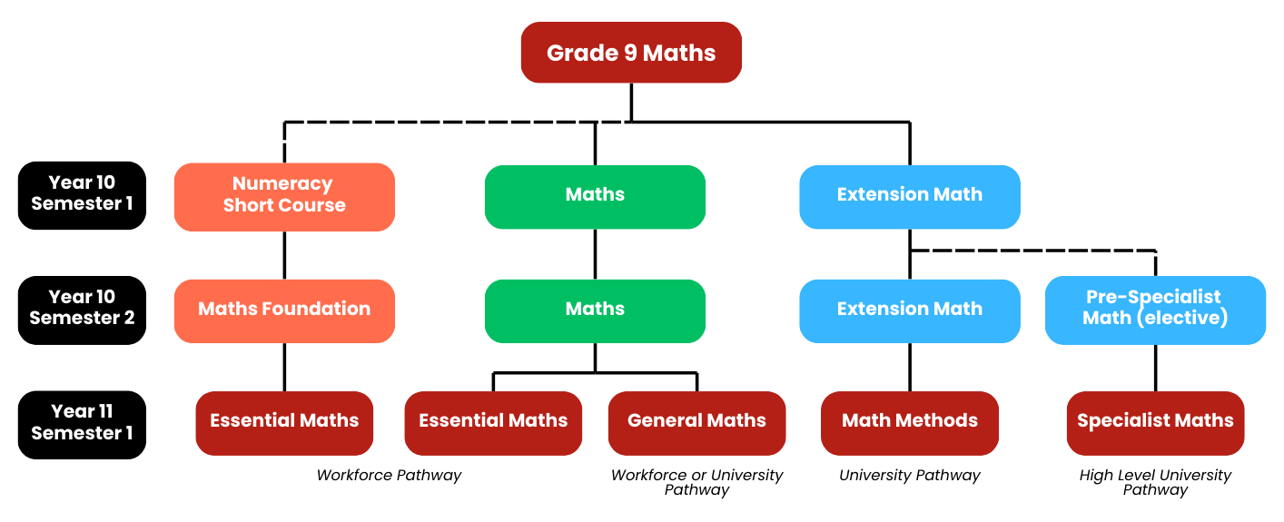

**Numeracy Short Course + Mathematic Foundations**

Numeracy Short Course is offered to students who have struggled with Mathematics throughout high school. Students are selected by the Head of Year and the Head of Department (Mathematics). The course focuses on building foundational skills in a meaningful context, helping students develop the ability to select and apply appropriate mathematics. Successful completion of the Numeracy Short Course provides students with their Numeracy Tick towards the Queensland Certificate of Education (QCE).

Students who successfully complete the Numeracy Short Course progress to Maths Foundations in Semester 2. Maths Foundations builds on the skills developed in Semester 1 and covers topics from the Australian Curriculum, preparing students for Essential Mathematics in Year 11.

For more information, please contact: Mr Michael McLaren, Head of Department Mathematics [mmcla62@eq.edu.au](mailto:mmcla62@eq.edu.au)

English Faculty

# English

The study of English is central to the learning and development of all students. It helps to create confident communicators, imaginative thinkers and informed citizens. English focuses on developing students’ analytical, creative and critical thinking and communication skills in all language modes. It encourages students to engage with texts from their contemporary world, with texts from the past and with texts from Australian and other cultures.

By the end of Year 10, students should have developed their ability to use English as active and informed citizens and are able to use language to:

* Participate as confident members of family and community life;
* Undertake further formal and informal study;
* Obtain employment or to participate in unpaid work;
* Be involved in satisfying recreational activities particularly those involving literature, drama and the mass media. how two news media texts represent a person, group, culture, places, events, objects and concepts.

**Literacy Short Course**

Some students will be offered a position in the Literacy Short Course to start at the beginning of Term 1. This offer will be based on a combination of Year 9 results, diagnostic testing, feedback from teachers and first term of Year 10 results. The Literacy Short Course will provide those students, who find English challenging, the opportunity to reinforce their literacy skills, in preparation for Year 11.

For more information, please contact: Ms Marianne Norvill, Head of Department English [mlnor0@eq.edu.au](mailto:mlnor0@eq.edu.au)

HPE Faculty

**Health and Physical Education**

The Year 10 curriculum builds on each student’s prior learning. During this time, students refine their understanding of how they can contribute to individual and community health and wellbeing. Students have frequent opportunities to participate in physical activities, including in outdoor settings, to value the importance of active recreation as a way of enhancing their health and wellbeing throughout their lives.

Students will engage in units of work with focusses on Physical Education, Health and Sport & Recreation.

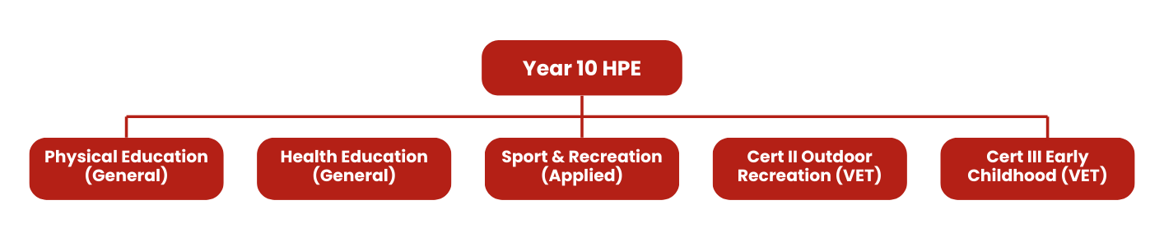

For more information, please contact: Mr Nathan Spencer, Head of Department Health and Physical Education [nspen31@eq.edu.au](mailto:nspen31@eq.edu.au)

Humanities and Languages Faculty

**History**

Promotes an understanding of societies, events, movements and developments that have shaped humanity from earliest times. Supports students to appreciate how the world and its people have changed, as well as the significant continuities that exist to the present day.

The study of history is based on evidence derived from remains of the past. It is interpretative by nature, promotes debate and encourages thinking about human values, including present and future challenges.

Transferable skills through historical inquiry: developing targeted questions; critical analysis and interpretation of sources; consideration of context; respect and explanation of different perspectives; developed and substantiated interpretations and effective communication.

This subject provides an introduction to the **general subjects** of Ancient History and Modern History.

Can lead to vocational areas such as: secondary school teacher, lawyer, journalist, archaeologist, librarian, museum curator, archivist, historic building inspector, conservator.

# Legal Studies (Civics & Citizenship)

Students compare the key features and values of Australia’s system of government to those of another system of government. They describe the Australian Government’s role and responsibilities at a regional and global level. They explain the role of the High Court of Australia. They explain how Australia’s international legal obligations influence the law and government policy. They identify and explain challenges to a resilient democracy and a cohesive society in Australia.

Students develop and refine a range of questions and locate, select and compare relevant and reliable information from a range of sources to investigate political and legal systems, and contemporary civic issues. They analyse information to evaluate perspectives and challenges related to political, legal or civic issues. They evaluate and compare the methods or strategies related to civic participation or action. Students use civics and citizenship knowledge, concepts and terms to develop descriptions, explanations and arguments that synthesise evidence from sources.

Pathways beyond school - tertiary studies, vocational education or workforce. Legal Studies can establish a basis for further education and employment in the fields of law, law enforcement, criminology, justice studies and politics.

Humanities and Languages Faculty

**Geography**

In Geography students explain how the interactions of people and environmental processes at different scales change the characteristics of places. They explain the effects of human activity on environments, and the effect of environments on human activity, over time. They evaluate the extent of interconnections occurring between people and places and environments. They analyse changes that result from these interconnections and their consequences. Students also evaluate strategies to address a geographical phenomenon or challenge, using environmental, social and economic criteria. They will use industry accepted geospatial technologies as a tool to discover what has happened, what is happening and what will happen.

This subject provides an introduction to the **general subject** of Geography. Can lead to vocational areas such as: analysts and technicians, data scientists, developers, environmental engineers, cartographers, communications professionals, civil engineers, surveyors, consultants, planners and designers, researchers and scientists, consultants and project managers.

# Chinese

The ability to communicate in an additional language such as Chinese is an important 21st century skill. Students develop knowledge, understanding and skills that enable successful participation in a global society. Communication in an additional language expands students’ horizons and opportunities as national and global citizens.

Studying Chinese contributes to and enriches intellectual, educational, linguistic, metacognitive, personal, social and cultural development. It requires intellectual discipline and systematic approaches to learning, which are characterised by effective planning and organisation, incorporating processes of self- management and self-monitoring.

Pathways: Tertiary studies, vocational education or work. A course of study in Chinese can establish a basis for further education and employment in many professions and industries. For example, those which value the knowledge of an additional language and the intercultural understanding it encompasses, such as business, hospitality, law, science, technology, sociology and education.

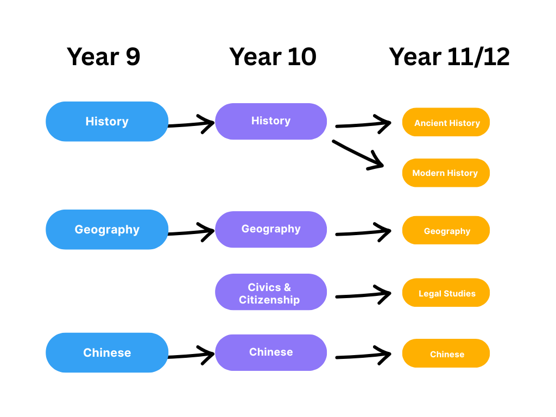

Humanities and Languages Faculty

# Economics & Business

Students analyse how economic indicators influence Australian Government decision-making. They explain ways that government intervenes to improve economic performance and living standards. They explain processes that businesses use to manage the workforce and improve productivity. They explain the importance of Australia’s superannuation system and its effect on consumer and financial decision-making. Students analyse factors that influence major consumer and financial decisions, and explain the short- and long-term effects of these decisions.

Students develop and modify a range of questions to investigate an economic and business issue. They locate, select and analyse relevant and reliable information and data from a range of sources. They interpret and analyse information and data to evaluate trends and economic cause-and-effect relationships, and make predictions about consumer and financial impacts. They develop an evidence-based response to an economic and business issue. They evaluate a response, using appropriate criteria to decide on a course of action. Students use economic and business knowledge, concepts and terms to develop descriptions, explanations and reasoned arguments that synthesise research findings.

The subject provides an introduction to the **general subjects** of Accounting and Business as well as the **applied subjects** of Business Studies and Tourism.

Can lead into vocational areas such as: accounting, business management, business development, banking, finance, business law, economics, entrepreneurship, business analytics, marketing, human resource management, business information systems, international business and commerce, tourism, event co-ordination.

For more information, please contact: Ms Andrea Powell or Mrs Michelle Pipe, [Head of Humanities](mailto:kvanz5@eq.edu.au) and Languages [apowe109@eq.edu.au](mailto:apowe109@eq.edu.au) or [mjpip0@eq.edu.au](mailto:mjpip0@eq.edu.au)

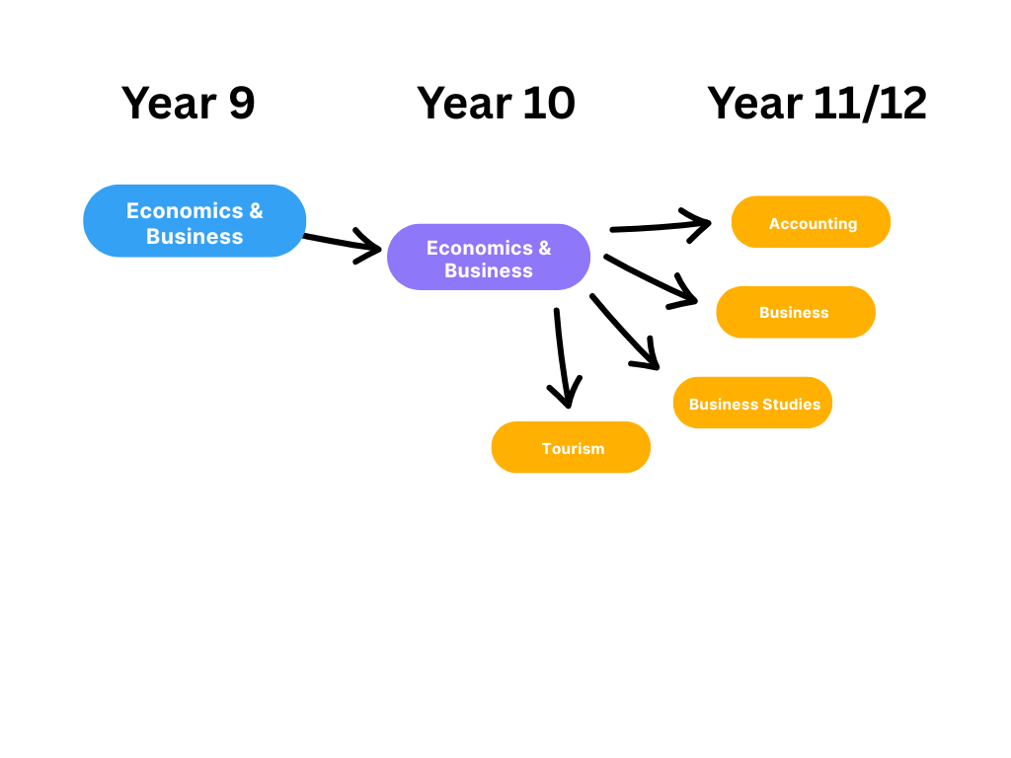

Vocational Education

# Cert II in Health Support Services

We are also offering a (delivered at school at no cost attaining up to 4 QCE credits). The program utilises Government funding (VETiS). This program will be delivered one day per week for the full year.

This program is delivered by Axiom College, RTO 40489.

This qualification reflects the role of workers who provide support for the effective functioning of health services. At this level workers complete tasks under supervision involving known routines and procedures or complete routine but variable tasks in collaboration with others in a team environment.

For more information, please contact: Mrs Kimberly Vanzetta, Head of External Partnerships and Career Pathways [kvanz5@eq.edu.au](mailto:kvanz5@eq.edu.au)

Special Education

**Special Education English**

Over the course of the year students explore a number of topics including creating a folio of work comparing the values, beliefs and attitudes of characters within film, writing an imaginative short story about the current state of the world, persuading readers through a letter about the importance of addressing social issues and an in-depth exploration of poetry culminating in a poetic analysis and creation of their own poem.

**Special Education Math**

Students will develop an understanding of relationships between Money, Patterns, Fractions and the four operations. The will learn that number patterns can be used in multiple ways to work out algebra, problem solving and how these various mathematical patterns can be a mix of any of the four operations. Students will examine and compare how Money has decimals and is part of everyday real-life Maths. They continue learn that numbers have patterns and meaning is associated with problem solving. Students see the links to life through the use of fractions in budgets, understanding portions and amounts of a whole.

**Special Education Science**

Throughout the year students learn about and investigate a variety of topics including cell structures, DNA, gene and inheritance patterns demonstrating their knowledge through short response, using a collection of work for a folio they develop an understanding of elements in the periodic table, through a research project they explore technologies of past and present and investigate technologies of the future and finally students will learn about mining and mining resources as they renewable and non-renewable resources.

**Special Education Civics**

Students begin this year exploring the events and developments that led to the formation of Australia as a nation through a source evaluation in class. Next, through a case study research task, students delve in learning about natural disasters across the globe and how these events impact individuals and communities. Adding to their Civics journey, students learn about the role of consumers and producers in the business industry and their impact in the Australian economy. To finish out the year, students study Viking culture and history including learning about the aspects of their daily life, artefacts, landmarks, mythology, etc. Leading students to create a research task on one of these aspects and create a Viking artefact.

**Work Preparation**

Students begin to explore their employment options as young adults preparing to exit school-based education services. Students are encouraged to develop workplace practices and skills to enhance their employment opportunities. There is a large emphasis on work place health and safety, developing resumes and preparing for job applications and interviews.

**Life Skills**

Students will develop skills necessary to function successfully as autonomous individuals within the home and community. Students develop an understanding of practices that impact on their health, safety and independence. Students will develop an understanding of day to day practices such as cooking, cleaning, sewing, budgeting and health management.

**Project**

Students acquire skills on how to create small projects safely using tools and other hands on methods. Specific skills in hands-on activities are fostered and cater for individual students and their personal interests. Skill areas include day to day practical tasks such as garden maintenance, animal management, painting and basic construction.

SEP students may choose Special Education Life Skills, Special Education Project and or/Special Education Work Prep as their elective choices.

For more information, please contact: Ms Shannon Potgieter, Deputy Principal [sxpot0@eq.edu.au](mailto:sxpot0@eq.edu.au)